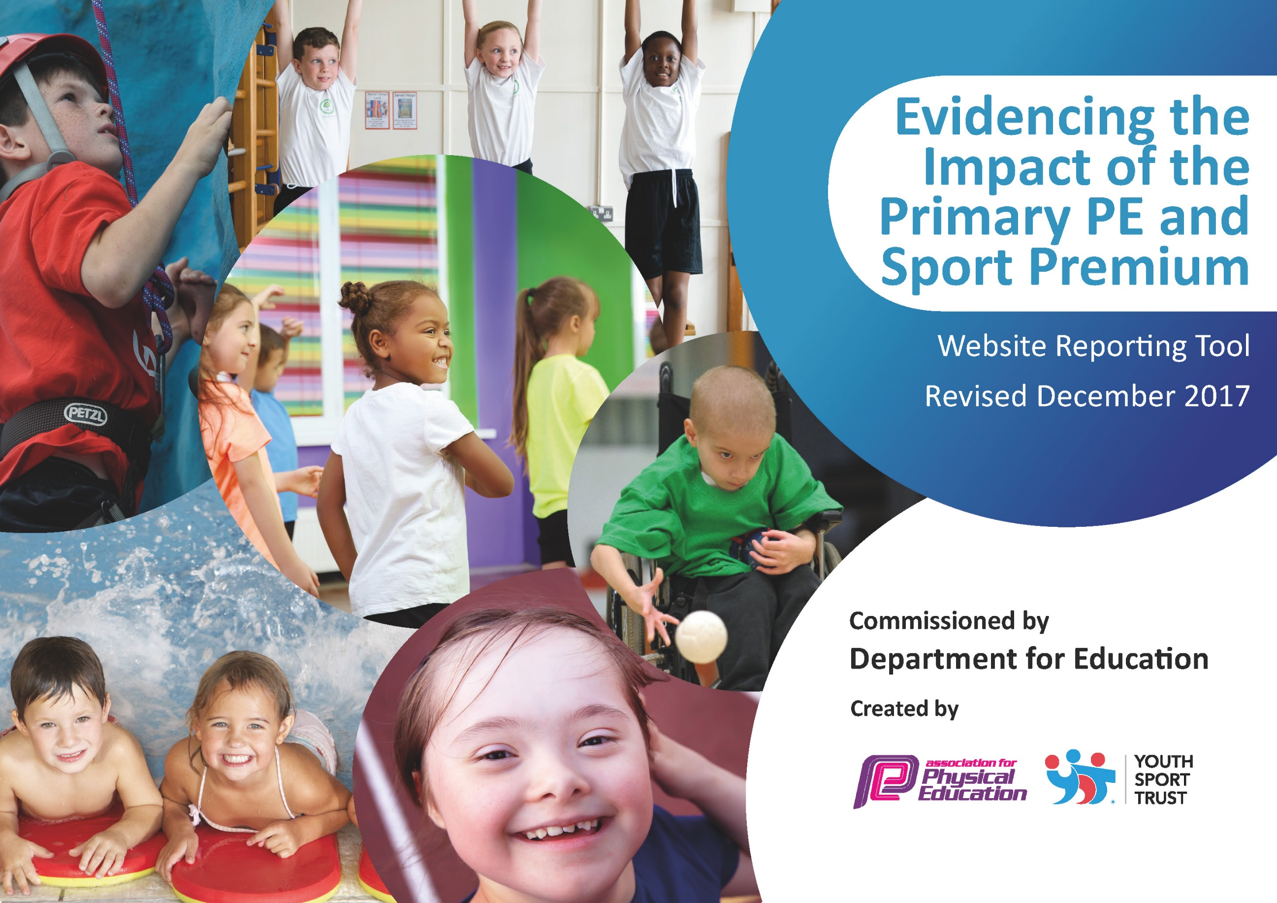

Schools must use the funding to make additional and sustainable improvements to the quality of PE and sport they offer. This means that you should use the Primary PE and Sport Premium to:

- develop or add to the PE and sport activities that your school already offers
- build capacity and capability within the school to ensure that improvements made now will benefit pupils joining the school in future years

Please visit gov.uk for the revised DfE guidance including the 5 key indicators across which schools should demonstrate an improvement. This document will help you to review your provision and to report your spend. DfE encourages schools to use this template as an effective way of meeting the reporting requirements of the Primary PE and Sport Premium.

We recommend you start by reflecting on the impact of current provision and reviewing the previous spend.
Under the Ofsted Schools Inspection Framework, inspectors will assess how effectively leaders use
the Primary PE and Sport Premium and measure its impact on outcomes for pupils, and how effectively governors hold them to account
for this.

Schools are required to publish details of how they spend this funding as well as on the impact it has on pupils’ PE
and sport participation and attainment.
We recommend regularly updating the table and
publishing it on your website as evidence
of your ongoing review into how you are using the money
to secure maximum, sustainable impact. To see an example of how to complete the table please click HERE.

Support for review and reflection - considering the 5 key indicators from DfE, what development needs are a priority for your setting and your students now and why? Use the space below to reflect on previous spend, identify current need and priorities for the future.

Key achievements to date: | Areas for further improvement and baseline evidence of need:
- Play-leaders now trained and active playtimes taking place every day  - New equipment to be ordered to enable us to deliver a rich and varied PE curriculum  - Multiple festivals attended through Dartmoor Schools Sports Partnership for all children  - Events attended for disengaged pupils through Dynamic School Games  - Climbing booked for FS and KS1and Kayaking booked for KS2 as an alternative sport to try  - Children have had the opportunity to try either a fencing or archery taster session  - Year 5/6 children have attended a parkour taster session  - Variety of new sporting clubs arranged for children  - Sporting achievements now being celebrated in praise assembly  - PE notice board being kept up to date with photos of children at events and children’s sporting achievements | - Staff to have training to improve confidence  - Planning to be obtained from all members of staff and observations to become more regular  - New rolling programmes in line with Saints South West to be created

Meeting national curriculum requirements for swimming and water safety | Please complete all of the below*:
What percentage of your current Year 6 cohort swim competently, confidently and proficiently over a distance of at least 25 metres? | 11/13  85%
What percentage of your current Year 6 cohort use a range of strokes effectively [for example, front crawl, backstroke and breaststroke]? | 11/13  85%
What percentage of your current Year 6 cohort perform safe self-rescue in different water-based situations? | 11/13  85%
Schools can choose to use the Primary PE and Sport Premium to provide additional provision for swimming but this must be for activity over and above the national curriculum requirements. Have you used it in this way? | No
Action Plan and Budget Tracking
Capture your intended annual spend against the 5 key indicators. Clarify the success criteria and evidence of impact that you intend to measure to evaluate for students today and for the future.

Academic Year: 2017/18 | Total fund allocated: £17,708.57 | Date Updated: 28th March 2018
Key indicator 1: The engagement of all pupils in regular physical activity – Chief Medical Officer guidelines recommend that primary school children undertake at least 30 minutes of physical activity a day in school |  |  |  | Percentage of total allocation:
 |  |  |  | 36%
School focus with clarity on intended impact on pupils: | Actions to achieve: | Funding allocated: | Evidence and impact: | Sustainability and suggested next steps:
- Introduce wake and shake for all pupils before morning registration to make sure all children are getting at least 5 minutes of exercise before starting the school day  - New PE equipment ordered to ensure there is enough for every children to take part in all areas of PE  - Continue to be part of the DSSP with support from their experienced coaches  - Offer a variety of after school clubs that appeal to vast amount of children such as parkour, netball and dance | - Wake and Shake CDs to be purchased  - Large speaker to be purchased  - PE equipment to be checked and new equipment to be ordered by Megan Jones  - Liaise with Sam Lyndon to arrange for him to come and teach some PE sessions  - Survey children to find out what clubs they would like to attend  - Arrange for coaches to come in and teach after school clubs | £258.25  £164.98  £1,500.87  £3,995  £380  £6,299.10 | - All children taking part in daily physical activity  - Children able to access a wider variety of sporting activities within the school grounds such as netball  - Children receiving high quality teaching of PE lessons  - Teachers given the opportunity to observe high quality PE lessons  - Children who previously did not attend after schools sports clubs now attending | Wake and Shake firmly embedded within school routine  More availability of a variety of different resources meaning teachers can deliver higher quality lessons for a variety of different sports  Teachers able to deliver higher quality lessons after observing Sam Lyndon  Continue any popular clubs where possible. Offer new clubs to attract disengaged pupils
Key indicator 2: The profile of PE and sport being raised across the school as a tool for whole school improvement |  |  |  | Percentage of total allocation:
 |  |  |  | 16%
School focus with clarity on intended impact on pupils: | Actions to achieve: | Funding allocated: | Evidence and impact: | Sustainability and suggested next steps:
- Sharing any in school and out of school sporting achievements  - PE/sport display constantly updated with achievements and photographs  - Visit from a sporting hero  - Staff to have PE kits supplied with school logo to give positive examples to the pupils about dress for sporting activities. All staff identifiable at sporting events.  - Play-leaders to be trained and supplied with caps/bibs to make them identifiable in the playground  - Introduce sports and healthy living week | - Achievements celebrated in assembly. Tablet computers purchased to take photos and record videos  - Encourage children to bring in any certificated/medals  - Give some year 6 children the responsibility to keep the board updated.  - Arrange for a sporting hero to visit the whole school  - Get quotes for hoodies and polo shirts and order for 6 staff  - Organise play-leader training with Sam Lyndon and order bibs for play-leaders  - Organise a variety of different events including activity day for FS and KS1 and one for KS2 | £1,100  £180  £30  £1,500  £2810.00 | - Children having a sense of the importance of sport outside of school  - Children keen to bring in and share sporting achievements from outside school  - Photographs of children with sporting awards displayed in the hall area for all to see  - Encourage children to try new sports  - Show children the benefits of eating and living healthily  - Showing children the importance of wearing the correct kit  - Being proud to represent the school at sporting events  - Children feel a sense of pride and responsibility at playtimes and lunchtimes  - Encourage children to try new sports  - Show children the benefits of eating and living healthily | Introduce sports achiever of the half term  Train up year 5 children in the Summer term ready for Autumn term when they are year 6  Children introduced to new sports and local groups that they can join

Key indicator 3: Increased confidence, knowledge and skills of all staff in teaching PE and sport |  |  |  | Percentage of total allocation:
 |  |  |  | 36%
School focus with clarity on intended  impact on pupils: | Actions to achieve: | Funding  allocated: | Evidence and impact: | Sustainability and suggested  next steps:
- CPD session delivered by Tim Flint (Dynamic sports) to increase staff confidence when delivering PE sessions  - Megan Jones to attend ‘Developing your Confidence in PE’ course to inform on planning and rolling programme therefore enhancing curriculum for all  - Jade Dewar and Jen Bradshaw to attend ‘Mini Yoga’ course  - CPD sessions available as part of SDSSP to develop confidence of staff where necessary  - Saints Southwest Partnership to deliver PE sessions 1 day per week and offer CPD | - Find out what areas staff are least confident with and arrange CPD session with Tim  - Arrange supply cover so MJ can attend course  - Arrange supply cover for 2 members of staff for 1 afternoon (1 paid 1 TA)  - Make staff aware of CPD opportunities  - TC to confirm details with Saints Southwest. PLT to create rolling programme and calendar of events | £2,000  £150  £120 supply  £100 training  (Part of DSSP allocation)  £4,000  £6,370.00 | - Staff to feel more confident delivering PE sessions  - Relay information and tips to staff during staff meeting  - Ideas for warm up games/behavior management techniques  - New free club available for children to attend  - Staff to feel more confident delivering PE sessions  - Staff to get new ideas/strategies for PE  - Children to have high quality PE sessions  - Inter-school festivals to be arranged | Teachers are more confident delivering PE sessions and will deliver higher quality lessons  Set up a yoga after school club  Staff who attend can relay information/tips etc to other staff members  Staff members get good quality CPD sessions to enable them to deliver more effective PE lessons
Key indicator 4: Broader experience of a range of sports and activities offered to all pupils |  |  |  | Percentage of total allocation:
 |  |  |  | 8%
School focus with clarity on intended  impact on pupils: | Actions to achieve: | Funding  allocated: | Evidence and impact: | Sustainability and suggested  next steps:
- Opportunity for year 5/6 children to try parkour to see if it is a sport they are interested in  - Premier sports to teach archery session to FS and KS1 and fencing to all of KS2 to show children the variety of sports available to them  - Arrange for some disengaged pupils to attend a variety of sporting events to get them more active  - Dynamic Sports KS2 event day to give the opportunity to try some multi-cultural sports  - Transport costs to all off site events | - Contact Kyle and arrange a date for him to come into school and teach children  - Contact Alistair at Premier and arrange for him to come in and teach each class 1 ‘alternative’ sport session  - Find a variety of different sports for disengaged children to have a go at –badminton, bench ball, kwik cricket etc  - Organise a convenient date with Tim  - Vicky to book competitively priced transport for events where necessary | (Part of Dynamic Sports allocation)  (Part of Dynamic Sports allocation)  £ 1,500  £1,500 | - Children now interested in parkour and have signed up to the after school club  - Children have the opportunity to try a wide range of sports that they wouldn’t normally try  - Children who would normally shy away from sports to be engaged in exciting, new sporting activities  - Team building for the whole of KS2  - Try new activities that they haven’t previously  - Children able to get to a variety of sporting events, competing against children from multiple schools | Offer an after school club if popular  Children may find a passion for a new sport  Look at possibly running an after school club for one of these sports
Key indicator 5: Increased participation in competitive sport |  |  |  | Percentage of total allocation:
 |  |  |  | 4%
School focus with clarity on intended  impact on pupils: | Actions to achieve: | Funding  allocated: | Evidence and impact: | Sustainability and suggested  next steps:
- Introduce inter-house competitions for a variety of sports to engage pupils and give them the opportunity to play against children from different schools  - SDSSP Competitive events attended to engage more pupils  - Staff cover for PE events out of school | - Organise with Tim Flint  - Make sure children are booked onto events and staff are available to take them where necessary  - Organise staff cover for events | (Part of Dynamic Sports allocation)  (Part of DSSP allocation)  £700  £700 | - Children to be able to play a variety of different sports against new teams  - Children given the opportunity to be competitive and win competitions  - Children get to use the skills they have gained through their PE sessions to have competitive games against other schools  - Children able to attend events as staff members are made available  £17,479.10 allocated  £29.47 remaining | Maintain competitive sports events with other trust schools.  Link with community sports clubs to promote continuation of participation.

