Harbertonford Primary
Behaviour statement
(Relational Management Statement)
This statement applies to staff, pupils, parents and governors.
Our Rationale
The fundamental principle underpinning our Relational Behaviour approach at Harbertonford is establishing strong, positive, open relationships between the members of our community (staff, pupils and families).
We believe that behaviour learning takes place in the conversation and understanding; co-operation is more valuable than conflict. These principles allow us to discuss negative behaviour incidents calmly and proactively, on an incident-by-incident basis, through restorative conversations, and, if needed agree appropriate reparations or consequences with the child, rather than impose sanctions. Rewards are given as an expression of gratitude for positive behaviour, with children fully understanding the behaviour being recognised and why.
We have three clear expectations:
- Be ready
- Be respectful
- Be safe
All behaviour is discussed with explicit reference to one or more of these expectations.
Through approaching behaviour this way, we ensure that children learn, develop and make long term choices through an understanding of impact, rather than respond to a punitive or generic reward system.
Aims

- To ensure that all children and adults have a sense of belonging, feeling safe, secure and valued.
- To provide a clear, fair and consistent approach to behaviour.
- To encourage pupils to develop positive behaviour for learning in recognition of its importance as a lifelong skill.
- To enable staff to support children with their behaviour through providing students with strategies to manage their own behaviour.
- To foster, nurture and value strong and healthy relationships.
- To recognise that being ‘fair’ is not about everyone getting the same (equality) but about everyone getting what they need (equity).
- To develop responsibility and accountability for one’s own actions and their impact on others.
- To develop respect for other people, their views and feelings and circumstances.
- To develop empathy with the feelings of others affected by one’s own actions.

Relational Behaviour model
We follow the Devon model for relational practice.

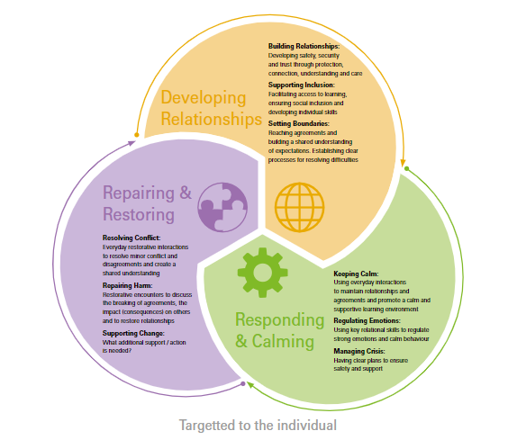

We recognise that behaviour is a form of communication and not all behaviours are a matter of “choice”. We recognise that most children self-regulate their behaviour, behave very well every day and never need reminding about how to behave appropriately. We want to encourage these children as well as support the children who may not behave appropriately sometimes to manage their behaviour positively.

Rewards
Pupils can be rewarded in a number of ways:
- verbal or written praise;
- being asked to share their work with other staff or pupil;
- Counters or links;
- learning reward stickers;
- achievements recognised in assemblies;
- rewards ceremonies;
- specific reward meetings e.g. house treat or bookflix
However, we understand that occasionally children will behave inappropriately for whatever reason. When children display this behaviour, there are several layers of consequences in place to encourage them to manage their behaviour in a positive way. We realise that sometimes this can be different for every child who has their own individual needs so may look different in each individual case.
Managing inappropriate behaviour
- Staff log incidents on the internal class chronology, which is seen by the DSL and deputy DSL;
- For some children ABC records are kept to enable the DSL, deputy DSL and SENDCo to support the class teacher in identifying trends and/or triggers;
- Children needing additional emotional support may have immediate informal support based on their current needs “at this point in time” or may have intervention support planned, which will be reviewed on a 6 weekly basis;
- Children may have a co-regulation plan, written in conjunction with the SENDCo and shared with all staff;
- The context of the situation is always taken into account;
- Time will be made for a restorative conversation to take place with the child and with any other child directly affected by the incident;
- All staff have the agreed list of restorative questions in their lanyard at all times;
- All parties will have the opportunity to be listened respectfully during the restorative process;
- Consequences and actions that will repair the situation will be chosen and agreed by all parties;
- If child on child abuse has taken place, general feedback will be given to the parents involved. It will be made clear to the parents that the situation was dealt with in a restorative manner and that all parties involved feel the situation has been resolved.
Expectations
Caring for people:
We expect all pupils and adults to respect the feelings of others and to treat everyone as they would like to be treated. This includes all the members of our school community.

We expect pupils to:
- be respectful to one another and adults, speak calmly and courteously;
- work restoratively to avoid conflict and respect the rights of others to be different;
- listen to the views of others (as long as they are not of a prejudiced nature) and accept their right to hold those views;

We expect that staff will:
- be great role models for pupils and peers;
- support the school’s commitment to equity, equality and diversity, and encourage pupils to show respect for members of the community and the environment;
- speak politely and calmly and respect everyone's personal space;
- develop positive relationships with pupils, parents, colleagues, governors and visitors;
- treat all members of the community equally, fairly and consistently, meeting their individual needs.

We expect that parents and carers will:
- work with the school to support pupils in making wise and informed decisions that impact their attendance, achievement and well-being;
- work with the school to ensure their child follows school expectations and procedures; see ‘caring for people’ and ‘caring for the building and environment’ and ‘caring for property’;
- encourage their child to show respect for all members of the community and the environment;
- support the school in modelling polite, positive relationships;
- work in partnership with school staff to ensure that their child is able to achieve to the best of their ability.
- be good role models for other members of the community;

Caring for the building and environment
We expect all pupils to respect the school building, facilities and equipment; to use the bins provided for litter and look after school property. Pupils who do not adhere to this are expected to contribute to the cost of any damage caused to school buildings or equipment.

Caring for property
We expect all pupils to respect other people’s work and property and to take pride in displays of work that are put up around the school. Pupils are asked to avoid bringing valuables into school.

